Příloha_3 – Obrázky ekologické stopy

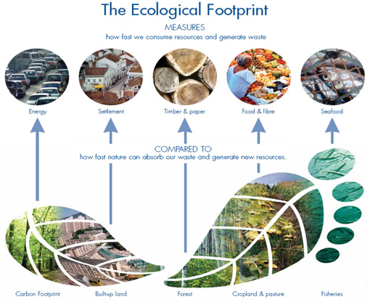
http://www.footprintnetwork.org/images/uploads/basics-overview-510.jpg
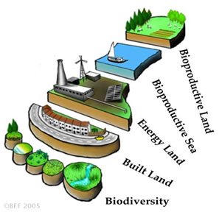
http://www.steppingforward.org.uk/tech/figs/fig3.jpg

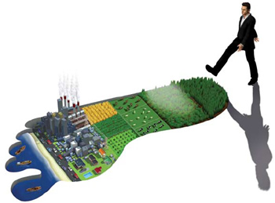
http://corbettcares.com/wp-content/uploads/2010/02/ecological-footprint-illustration.jpg

